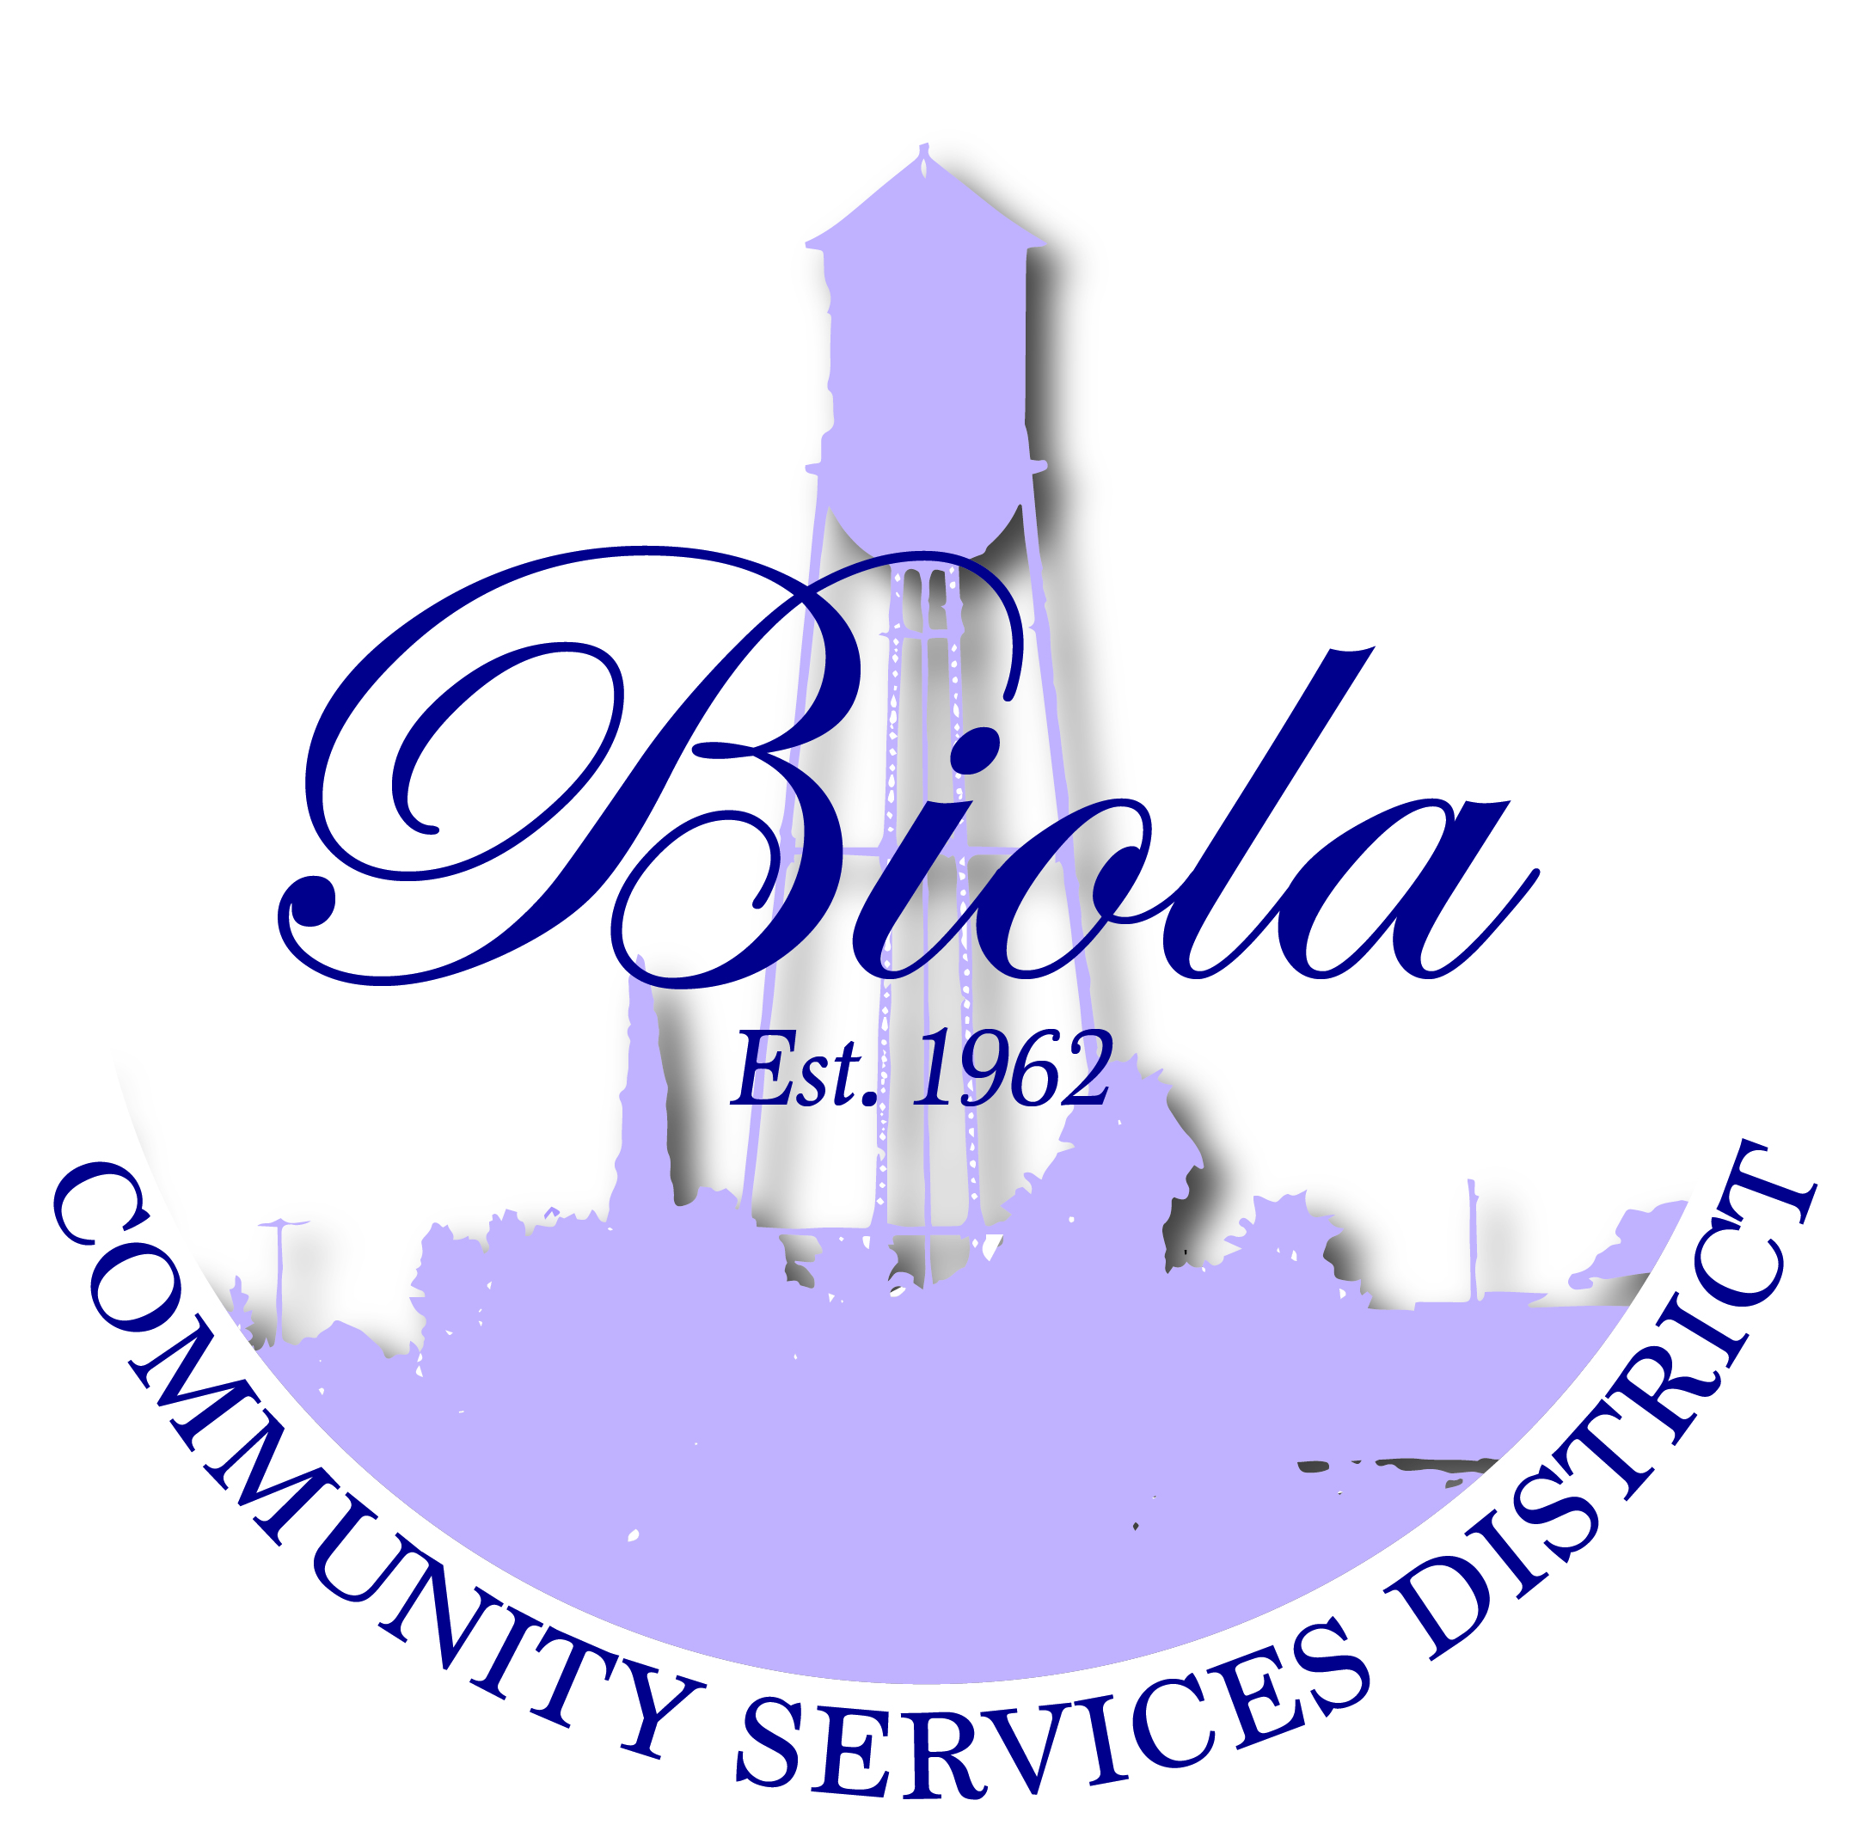

4925 N. Seventh Street Biola CA 93606
Office (559) 843-2657 Fax (559) 843-2275

Rey Lozano – President
Mercedes Ramos – Vice President
Rudy Hernandez – Treasurer
Monique Dolores – Board Member
Martha Madera – Board Member
Dwight Miller - Manager
Elaine Cervantes – Secretary

AGENDA AND NOTICE OF REGULAR MEETING
OF THE BOARD OF DIRECTORS

THURSDAY, JUNE 25, 2015
6:00 P.M.

A regular meeting of the Board of Directors of Biola Community Services District is hereby
called for Thursday, June 25, 2015 at the District’s office at 4925 N. Seventh Street, Biola,
CA at 6:00 P.M. Pursuant to the District’s Bylaws and Rules of Order, this Notice if Regular
Meeting shall be delivered to each Director not less than 72 hours in advance of
the meeting, and posted in the locations specified and at the District’s Office.

The Only business to be discussed at the meeting will be the matters listed below.

OPENING CEREMONIES

- Welcome – President Rey Lozano
- Pledge of Allegiance
- Call to Order
- Roll Call

- CERTIFICATION

Certification that the agenda was posted at least 72 hours before the meeting at Shaw Market,
Biola Community Center and Biola Post Office and was signed by Secretary to the
Board, Elaine Cervantes and was acknowledged to the Board President as being correct.

AGENDA APPROVAL/ADDITIONS/DELETINGS

- ADOPTION OF THE AGENDA – Regular Meeting, June 25, 2015

- REQUEST TO ADDRESS THE BOARD – This portion of the meeting is reserved for
members of the public to address the Board on item of interest that are not on the
Agenda and are within the subject matter of the Board.

- CONSENT CALENDAR

- Approval of Minutes of Regular Meeting of May 21, 2015
- Approval of Closed Session Minutes of Special Meeting June 9, 2015
- Review of Financial Reports as of May 31, 2015
- Approval of Contract with Cuttone & Mastro CPA for 2015/16
- Approval of Contract with Lozano Smith Attorney at Law

- OLD BUSINESS
A. None

- NEW BUSINESS

- Vote for the 2015 CSDA Board of Directors (California Special Districts Assoc.)
- Approval of 2015/2016 Budget
- Approval of Resolution No. 022015-02 (Authorize Representative for
Biola Water System Upgrade Grant)

- CORRESPONDENCE/ANNOUNCEMENTS

A. Reminder – Office closed for payments every Monday and Friday
B. Biola Farmers Market the 1st and 3rd Wednesday of the Month thru
September 2, 2015. Anyone wanting a booth please contact
Ernesto Gutierrez (559) 360-3139 the cost is $15.00

- DIRECTORS COMMENTS
- As Offered (Handout)

- CLOSED SESSION PURSUANT TO GOVERNMENT CODE SECTION 54956.9(h)
- To Consider the Appointment, Employment, Evaluation of Performance, Discipline, or
Dismissal of a Public Employee and to Hear Complaints against a Public Employee

- ADJOURNMENT
A. The next regular meeting of the Board of Directors will be on July 16, 2015

NOTE: The agenda items may not be presented in the order they are listed. Persons wishing to discuss an item that was taken out of order will have the opportunity to do so. All agenda items listed are considered to be discussion and/or action items. Material related to an item on this agenda that are public documents and are submitted after distribution and posting of the agenda are available for public inspection in the District’s office at 4925 N. Seventh Street Biola, CA 93606, during normal business hours. Documents that are public documents provided by others during a meeting will be available at the same location during business hours after the meeting.

Individuals needing special assistance in order to participate in this meeting should contact the District Secretary for such assistance or accommodation prior to the meeting.

Date:_____________________________, 2015 By:_____________________________________________
Reyes Lozano, President/Chairperson

