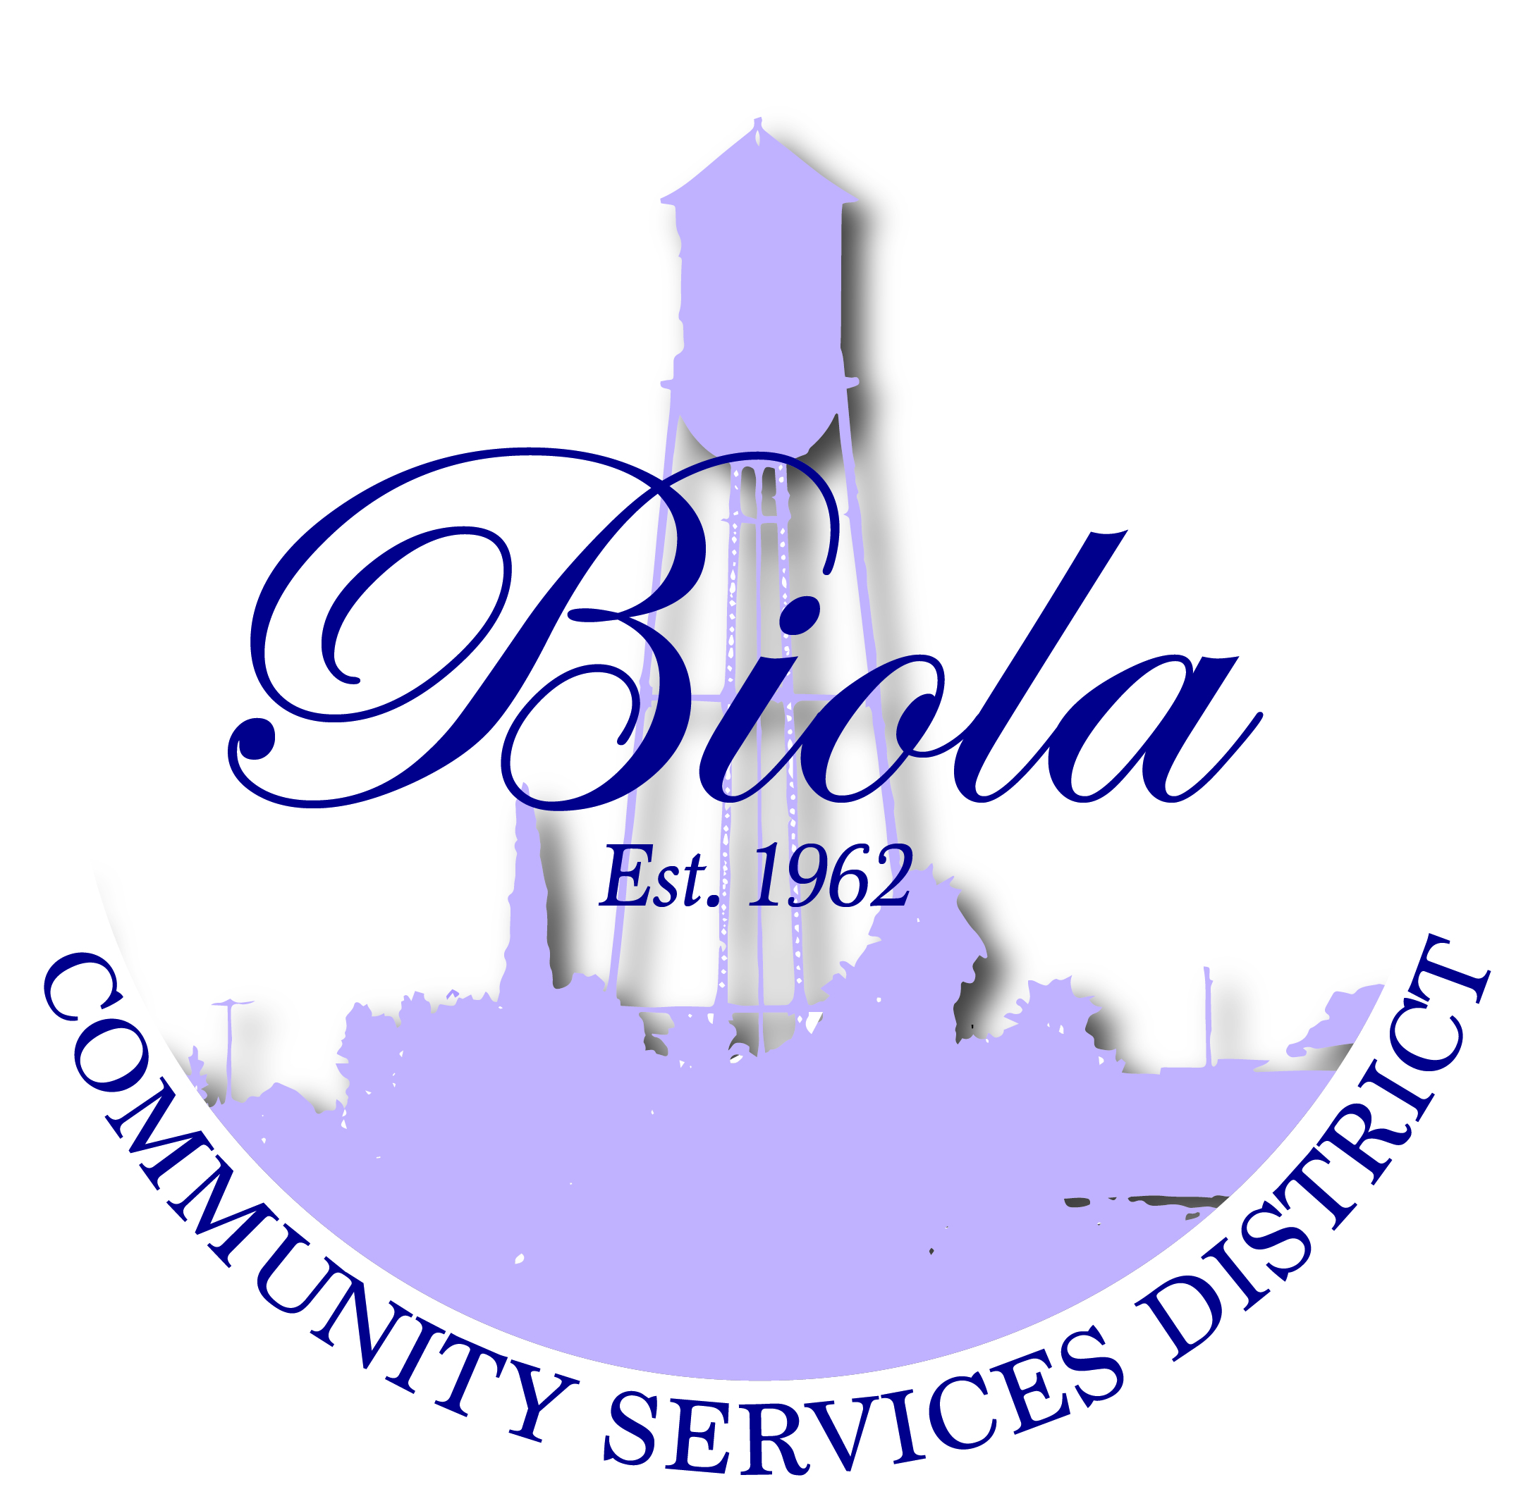

4925 N. Seventh Street Biola CA 93606
Office (559) 843-2657 Fax (559) 843-2275

Reyes Lozano – President
Mercedes Ramos – Vice President
Rudy Hernandez – Treasurer
Monique Dolores – Board Member
Martha Madera – Board Member
Dwight Miller - Manager
Elaine Cervantes – Secretary
MINUTES
SPECIAL MEETING
THURSDAY, August 6, 2015
6:00 P.M.

Present: President Lozano (RL), Madera (MM), Hernandez (RH),
Dolores (MD), Ramos (MR), Miller (DM), Cervantes (EC) Voting: Yes, No Absent (Abstain
Also Present: Gary Horn ( Yamabe & Horn Engineering Inc.) and Gabe Cervantes if needed)

OPENING CEREMONIES

- Welcome – President Rey Lozano
- Pledge of Allegiance Performed
- Call to Order 6:00P.M
- Roll Call All Present

AGENDA APPROVAL/ADDITIONS/DELETIONS
To accommodate members of the public or convenience in the order of presentation,
Items on the agenda may not be presented or acted upon in the order listed. Approved RH/MD
(Voted 5-0)

- PRESENTATION/CEREMONIAL MATTERS

REQUEST TO ADDRESS THE BOARD – This portion of the meeting is reserved for
members of the public to address the Board on item of interest that are not on the
Agenda and are within the subject matter of the Board.

- CONSENT CALENDAR None

- DEPARTMENT REPORTS – NEW BUSINESS

A-1 SUBJECT: Final acceptance for the 2013 CDBG Project for Biola Avenue
Project No. 13031 Water Lines
RECOMMENDATION: Board approved final acceptance for 2013 CDBG Project #13031 Approved RH/MM (Voted 5-0)

A-2 SUBJECT: Final acceptance for the 2013 CDBG Project for Third Street Project #13032
RECOMMENDATION: Board approved final acceptance for 2013 CDBG Project #13032 Approved RH/MM (Voted 5-0)

- SUBJECT: Approval of the Agreement for the 2015 CDBG Sidewalk Project #15031
RECOMMENDATION: Board approved the agreement for the 2015 CDBG Project Approved RH/MM (Voted 5-0)

- SUBJECT: Public Hearing for the 2016/2017 CDBG Applications opened with
Yamabe & Horn Engineering, Inc. for Fifth Street Water main and/or Opened 6:20pm
Sidewalk Project along the East Side of Biola Avenue
RECOMMENDATION: Board to close Public Hearing for CDBG 2016/2017 application Approved RH/MM (Voted 5-0)
Closed at 6:45pm
- SUBJECT: Approval of 2016/2017 CDBG Application for Fifth Street water main or
Biola Avenue sidewalk extension
RECOMMENDATION: Board approved to apply for the 2016/2017 CDBG Application
For the Biola Avenue Sidewalk Project with Yamabe & Horn Engineering, Inc. Approved MD/MM (Voted 4-1)

- SUBJECT: Public Hearing for Resolution No. 08-2015 Assessment of Annual Levy Opened 6:51pm
RECOMMENDATION: Board to close Public Hearing for Resolution No. 08-2015 Approved RH/MM (Voted 5-0)
Closed at 7:08pm
- SUBJECT: Approval of Resolution No. 08-2015 Assessment of Annual Levy
RECOMMENDATION: Board approved Resolution No. 08-2015 Assessment of Annual Approved RH/MD (Voted 5-0)
Levy

- COMMUNITY INFORMATION/STAFF COMMUNICATION

Reminder – New Office Hours; Monday office closed T/W/T 8am to 5pm
Friday 8am to 12noon

Biola Farmers Market the 1st and 3rd Wednesday of the Month thru
September 2, 2015 5:00pm to 9:00pm. Anyone wanting a booth please
Contact Eduardo Antunez (559) 408-0060 the cost is $10.00

National Night-Out was Wednesday, August 5, 2015 6:00pm to 8:00pm location was the
Biola Pavilion Center @ 12541 “G” Street, Biola. This event was sponsored by the Biola
Community Services District, VFW Post 5845, Biola Chamber of Commerce,
Biola Community Development Corporation and Biola Impact Youth Group

- DIRECTORS COMMENTS/BOARD REPORTS Handout

- CLOSED SESSION None

- ADJOURNMENT
- The next regular meeting of the Board of Directors will be on August 20, 2015@6:00pm Approved MR/MD
(Voted 5-0)
8:03pm
MINUTES CERTIFICATION

I, ELAINE CERVANTES, Secretary to the Board for the Community of Biola, do hereby declare
Under penalty of perjury that the above Minutes are a true report of all actions taken at the
Board of Directors meeting held on the first date above written at Biola Community
Services District, 4925 N. 7th Street, Biola, CA 93606
DATE: 8/10/15

_______ __________________________________________
Elaine Cervantes / Board Secretary

