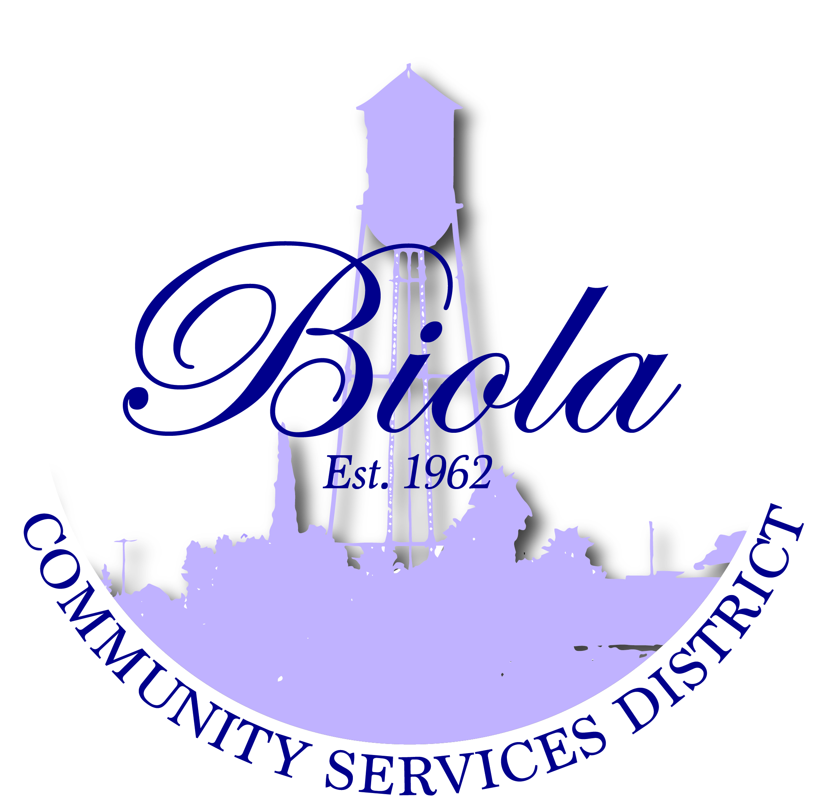

4925 N. Seventh Street-Po box 57 Biola CA 93606
Office (559) 843-2657 Fax (559) 843-2275

Reyes Lozano – President
Mercedes Ramos – Vice President
Rudy Hernandez – Treasurer
Monique Dolores – Board Member
Martha Madera – Board Member
Dwight Miller - General Manager
Elaine Cervantes – Board Secretary

AGENDA FOR REGULAR MEETING
OF THE BOARD OF DIRECTORS

THURSDAY, November 19, 2015
6:00 P.M.

A regular meeting of the Board of Directors of Biola Community Services District is hereby
called for Thursday, November 19, 2015 at the District’s office at 4925 N. Seventh Street,
Biola, CA at 6:00 P.M. Pursuant to the District’s Bylaws and Rules of Order, this Notice if
Regular Meeting shall be delivered to each Director not less than 72 hours in advance of
the meeting, and posted in the locations specified and at the District’s Office.

The only business to be discussed at the meeting will be the matters listed below.

OPENING CEREMONIES – 6:00 P.M.

- Welcome – President Reyes Lozano
- Pledge of Allegiance
- Call to Order
- Roll Call

- CERTIFICATION

Certification that the agenda was posted at least 72 hours before the meeting at Shaw Market,
Biola Community Center and Biola Post Office and was signed by Secretary to the
Board, Elaine Cervantes and was acknowledged to the Board President as being correct.

AGENDA APPROVAL/ADDITIONS/DELETINGS

- ADOPTION OF THE AGENDA – Regular Meeting, November 19, 2015

- REQUEST TO ADDRESS THE BOARD – This portion of the meeting is reserved for
members of the public to address the Board on item of interest that are not on the
Agenda and are within the subject matter of the Board.

- CONSENT CALENDAR

- Approval of Minutes of Regular Meeting October 15, 2015
- Approval of Financial Report as of October 31, 2015

- OLD BUSINESS
- BCSD Policy Handbook updates

- NEW BUSINESS
- Approval of Agreement with Yamabe & Horn Engineering, Inc., on the Biola Avenue
Sidewalk Extension Project No. 15031
- Approval of Agreement with Yamabe & Horn Engineering, Inc., on “E” and “G” Water
Lines, Project No. 14032
- Adoption of MOU between the Biola Community Services District, the
Fresno Irrigation District and other parties

- CORRESPONDENCE/ANNOUNCEMENTS

Reminder – New Office Hours; Monday office closed T/W/T 8:00am to 5:00pm
Friday 8:00am to 12noon

Fresno Food Bank Distribution was changed to Tuesday, November 24, 2015 at
8:00am at the Biola Community Center and December 9, 2015

VFW Post 5845 Toys for Tots, Sunday December 20, 2015 at 2:00pm to 5:00pm
For more information, please contact Phillip Cervantes

Neighborhood watch meeting Thursday, December 3, 2015 @ 6:00pm Biola
Community Center (Anthony Robles)

Mid-Valley Disposal Community Cleanup Saturday, December 12, 2015 8:00am-2:00pm

- DIRECTORS COMMENTS
- As Offered (Handout)

- CLOSED SESSION (GOVERNMENT CODE 54956.8)
A. Lease Agreement (Salwasser)

- ADJOURNMENT
A. The next regular meeting of the Board of Directors will be on December 17, 2015

NOTE: The agenda items may not be presented in the order they are listed. Persons wishing to discuss an item that was taken out of order will have the opportunity to do so. All agenda items listed are considered to be discussion and/or action items. Material related to an item on this agenda that are public documents and are submitted after distribution and posting of the agenda are available for public inspection in the District’s office at 4925 N. Seventh Street Biola, CA 93606, during normal business hours. Documents that are public documents provided by others during a meeting will be available at the same location during business hours after the meeting.

Individuals needing special assistance in order to participate in this meeting should contact the District Secretary for such assistance or accommodation prior to the meeting.

Date:_____________________________, 2015 By:_____________________________________________
Reyes Lozano, President/Chairperson

