DATES TO REMEMBER
Upcoming Events:
Oct 26: Food Distribution 4 pm – 6 pm
Oct 28-29: Community Clean-up (See Flyer attached)
Nov 7: Chamber of Commerce 6:30 pm
Nov 9: CCFB Food Distribution 9 am
Nov 9: VFW Meeting 6:00 pm
Nov17: BCSD Board Meeting 6:00 pm
Nov 23: Food Distribution 4 pm – 6pm
Nov 24 & 25: Thanksgiving Office Closed

FECHAS PARA RECORDAR
Próximos Eventos:
Oct 26: Distribución de Comida 4pm – 6pm
Oct 28-29: Limpieza de la Comunidad
Nov 7: Biola Camara de Comercio 6:30 pm
Nov 9: CCFB Distribución de Comida 9 am
Nov 9: VFW Junta 6:00 pm
Nov 17: BCSD Junta de Mesa Directiva 6:00 pm
Nov 23: Distribución de Comida 4pm - 6:00 pm
Nov 24 & 25: Día de Gracias Oficina cerrada.

Biola community services district

  - october / novemBER NEWSLETTER
BOLETÍN DE OCTUBRE / NOVIEMBRE

:

What is the Affordable Connectivity Program?
https://www.affordableconnectivity.gov

The Affordable Connectivity Program (ACP) is a U.S. government program run by the Federal Communications Commission (FCC) program to help low-income households pay for internet service and connected devices like a laptop or tablet. You are likely eligible if your household’s income is below 200% of the Federal Poverty Line, or if you or someone you live with currently receives a government benefit like SNAP, Medicaid, SSI, WIC, Pell Grant, or Free and Reduced-Price Lunch.
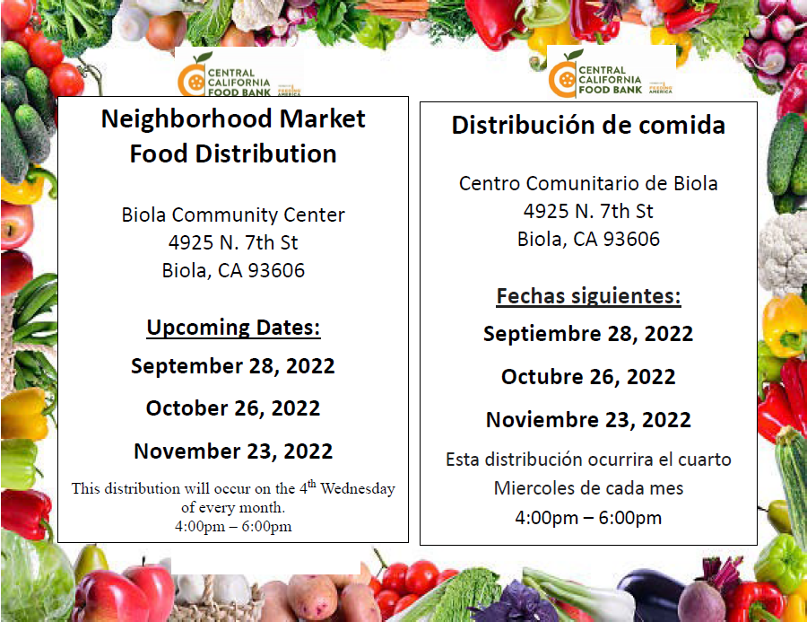

Effective June 1st, the new optional online payment system is available on our website. To register please visit www.biolacsd.org and follow the online payment steps. For assistance, please call the office. If a payment is not received by the 15th of every month, a late payment will be applied.
3 DAY WATERING SCHEDULE: April 1,2022 - October 31,2022
Addresses ending in odd numbers (1,3,5,7,9): Tuesdays, Thursdays, Saturdays. Addresses ending in even numbers (0,2,4,6,8): Wednesdays, Fridays, Sundays. NO WATERING between 10 a.m.- 6 p.m. and NEVER on MONDAYS.
“No parking in alley’s allowed, unauthorized alley parked cars will be towed away at owner’s expense.” “Prohibido estacionarse en el Callejon, autos estacionados en el Callejon seran remolcados al costo del dueño del auto.”
Please help us keep Biola Graffiti free. Report graffiti activity (559) 600-3111 Thank you
Ayúdenos a reportár el Grafiti. Por favor de llamar al (559) 600-3111 Gracias.
Thank you for your continuous efforts in keeping our Community of Biola clean, safe and sound, and for doing your part in keeping your property clean as we continue our TEAMwork. “Together Everyone Achieves More.”

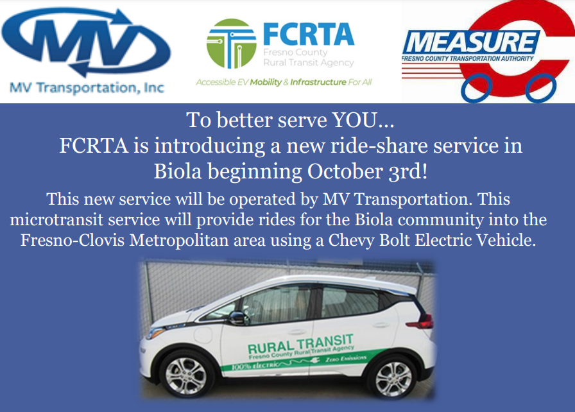
MV TRANSPORTATION IS NOW HIRING!
- Service Hours are 6 days a week (Monday – Saturday) 7am-7pm (subject to driver availability).
- If you are interested in becoming a driver for this service call 1-855-612-5184.

