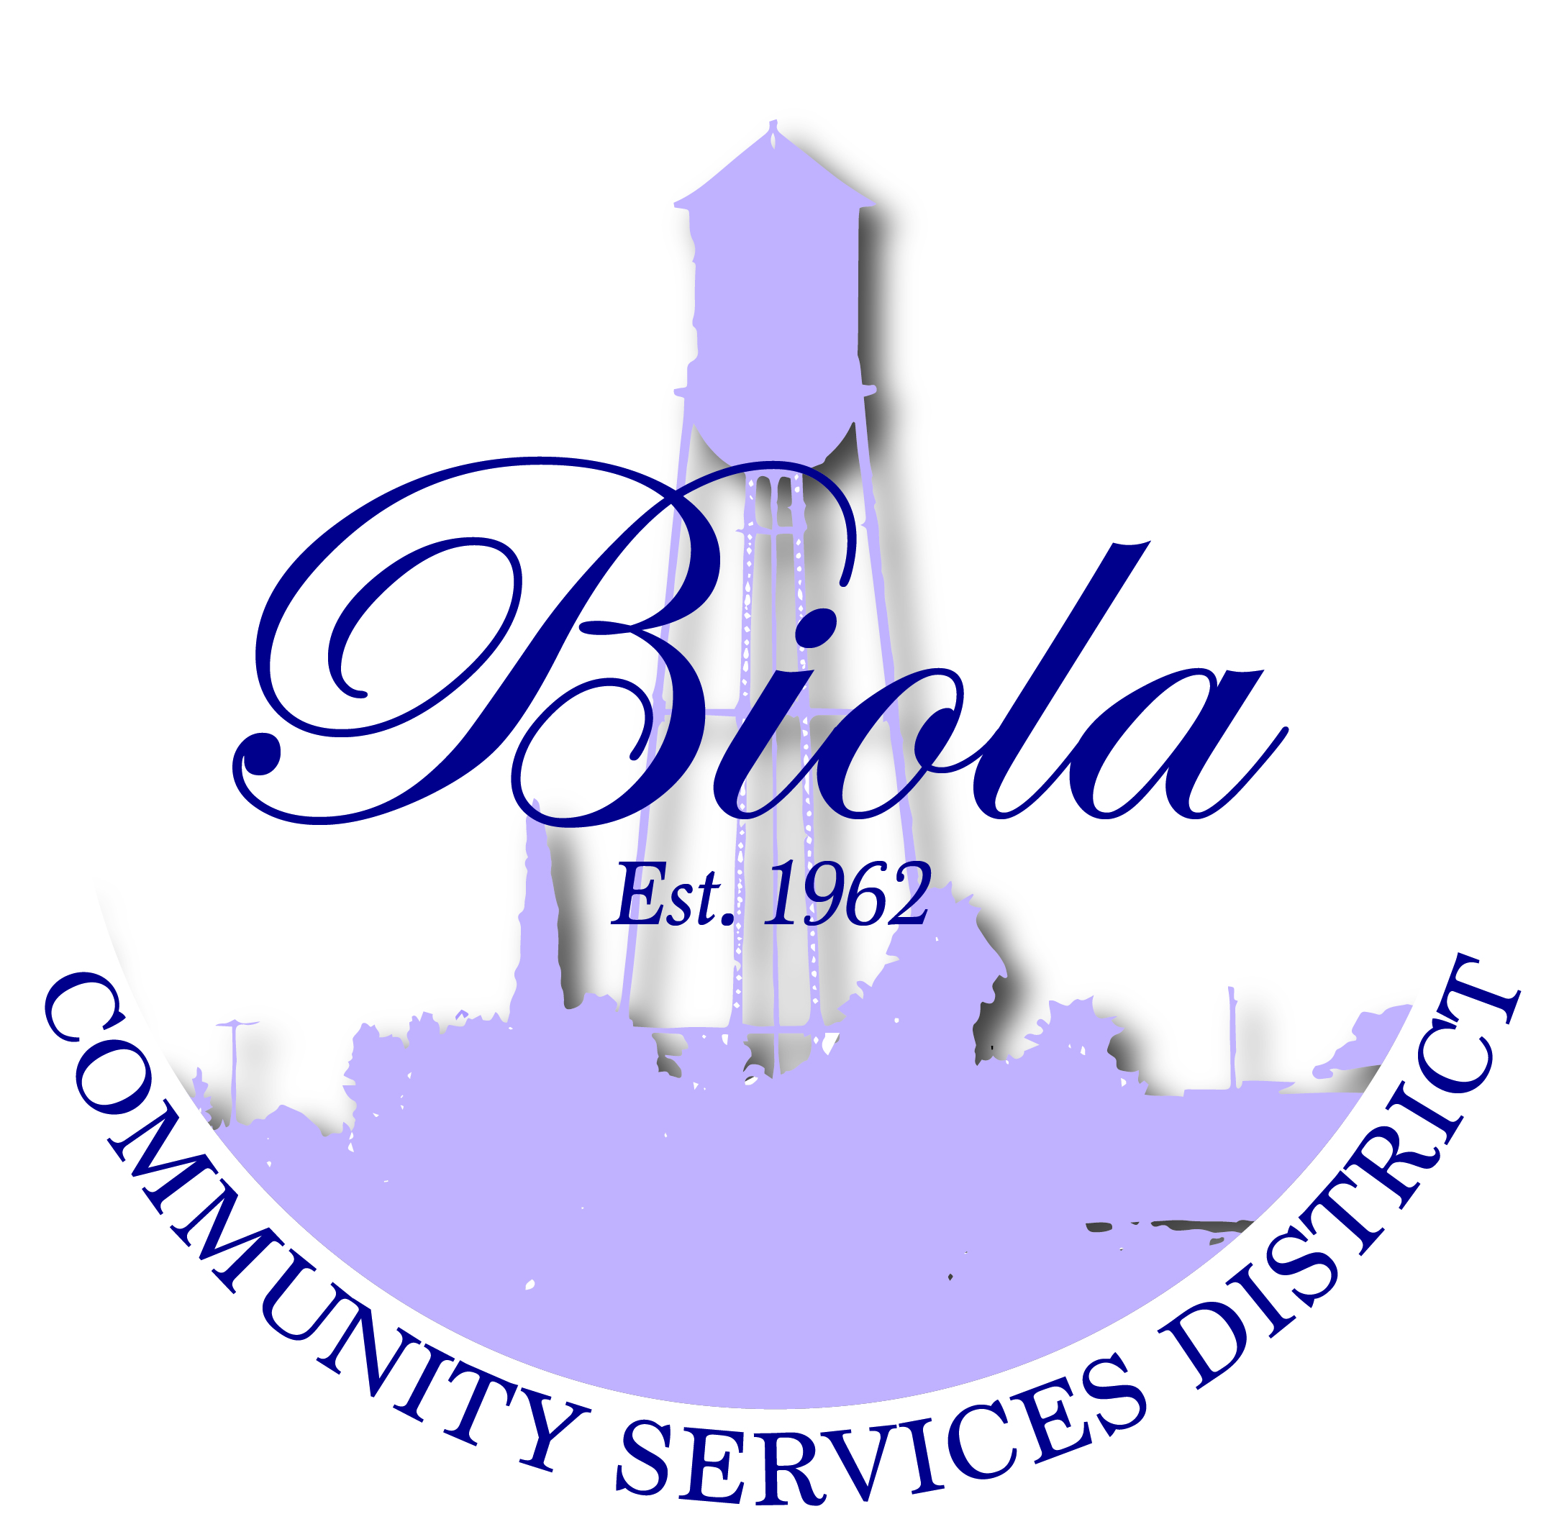

4925 N. Seventh Street-Po box 57 Biola CA 93606
Office (559) 843-2657 Fax (559) 843-2275

Reyes Lozano – President
Mercedes Ramos – Vice President
Rudy Hernandez – Treasurer
Monique Dolores – Board Member
Martha Madera – Board Member
Dwight Miller - General Manager
Elaine Cervantes – Board Secretary

AGENDA FOR REGULAR MEETING
OF THE BOARD OF DIRECTORS

THURSDAY, December 17, 2015
6:00 P.M.

A regular meeting of the Board of Directors of Biola Community Services District is hereby
called for Thursday, December 17, 2015 at the District’s office at 4925 N. Seventh Street,
Biola, CA at 6:00 P.M. Pursuant to the District’s Bylaws and Rules of Order, this Notice if
Regular Meeting shall be delivered to each Director not less than 72 hours in advance of
the meeting, and posted in the locations specified and at the District’s Office.

The only business to be discussed at the meeting will be the matters listed below.

OPENING CEREMONIES – 6:00 P.M.

- Welcome – President Reyes Lozano
- Pledge of Allegiance
- Call to Order
- Roll Call

- CERTIFICATION

Certification that the agenda was posted at least 72 hours before the meeting at Shaw Market,
Biola Community Center and Biola Post Office and was signed by Secretary to the
Board, Elaine Cervantes and was acknowledged to the Board President as being correct.

AGENDA APPROVAL/ADDITIONS/DELETINGS

- ADOPTION OF THE AGENDA – Regular Meeting December 17, 2015

- REQUEST TO ADDRESS THE BOARD – This portion of the meeting is reserved for
members of the public to address the Board on item of interest that are not on the
Agenda and are within the subject matter of the Board.

- CONSENT CALENDAR

- Approval of Minutes of Regular Meeting November 19, 2015

- OLD BUSINESS
- Approval of Financial Report as of November 30, 2015
- BCSD Freezer/Ice Machine (Update)
- BCSD Training – January 24 -27th Palm Springs
- Yamabe & Horn Engineering, Inc.
- Draft agreement with the VFW for an exclusive plan for Hall Management
- Approval of revised contract with BCSD and Keri Salwasser

- NEW BUSINESS
- Approval of Notice of Exemption (NOE) from CEQA for a Planning Study Application
to the State Water Board for the BCSD Water System Upgrades
- Approval of Kings Basin Water Authority contribution of $250.00

- CORRESPONDENCE/ANNOUNCEMENTS

Reminder – New Office Hours; Monday office closed T/W/T 8:00am to 5:00pm
Friday 8:00am to 12noon

VFW Post 5845 Toys with Santa, Sunday December 20, 2015 from 12:00noon to
3:00pm For more information, please contact Phillip Cervantes

The BCSD office will be closed December 24th and 25th for Christmas Holiday and on
December 31st and January 1st

- DIRECTORS COMMENTS
- As Offered (Handout)

- CLOSED SESSION
None

- ADJOURNMENT
A. The next regular meeting of the Board of Directors will be on January 21, 2016

NOTE: The agenda items may not be presented in the order they are listed. Persons wishing to discuss an item that was taken out of order will have the opportunity to do so. All agenda items listed are considered to be discussion and/or action items. Material related to an item on this agenda that are public documents and are submitted after distribution and posting of the agenda are available for public inspection in the District’s office at 4925 N. Seventh Street Biola, CA 93606, during normal business hours. Documents that are public documents provided by others during a meeting will be available at the same location during business hours after the meeting.

Individuals needing special assistance in order to participate in this meeting should contact the District Secretary for such assistance or accommodation prior to the meeting.

Date:_____________________________, 2015 By:_____________________________________________
Reyes Lozano, President/Chairperson

