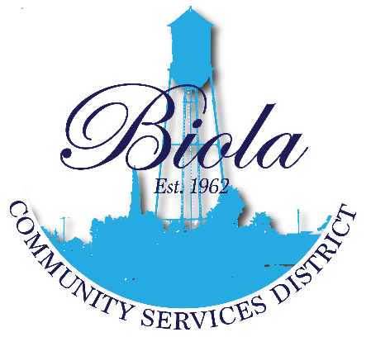

NOTICE OF PUBLIC HEARING FOR THE BIOLA COMMUNITY SERVICES DISTRICT TO CONSIDER NEW SIDEWALK
PROJECTS

PRESS RELEASE/PUBLIC NOTICE

BIOLA COMMUNITY SERVICES DISTRICT
to Consider Proposals for CDBG Funds

The Biola Community Services District will hold a public hearing to consider projects that could be funded by the Federal Community Development Block Grant (CDBG).

The Meeting will be held on August 18, 2022, at 6:00p.m. in the Biola Community Center located at 4925 N. 7th Street Biola, CA 93606. Interested individuals and organizations are encouraged to attend to voice their recommendations for their community/neighborhood.

For further information, please contact the Biola Community Services District at (559) 843-2657 or the Fresno County Community Development office at (559) 600-4292.

