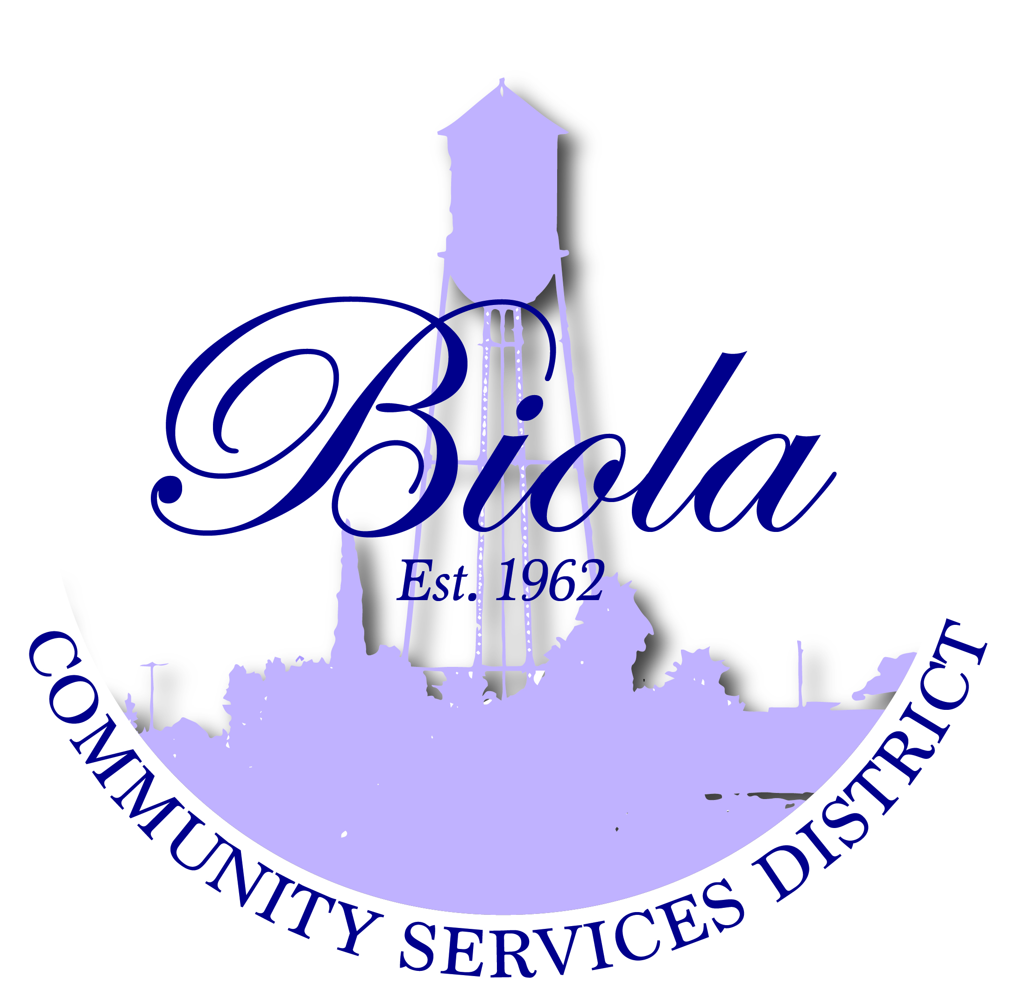

4925 N. Seventh Street Biola CA 93606
Office (559) 843-2657 Fax (559) 843-2275

Rey Lozano – President
Mercedes Ramos – Vice President
Rudy Hernandez – Treasurer
Monique Dolores – Board Member
Martha Madera – Board Member
Dwight Miller - Manager
Elaine Cervantes – Secretary
MINUTES
REGULAR MEETING
THURSDAY, JUNE 25, 2015
6:00 P.M.

Present: President Lozano (RL), Madera (MM), Hernandez (RH),
Dolores (MD), Ramos (MR), Miller (DM), Cervantes (EC) Voting: Yes, No Absent (Abstain
Also Present: Ermadina Rivas, Mae Morita, Gabe Cervantes and Phil Cervantes if needed)

OPENING CEREMONIES

- Welcome – President Rey Lozano
- Pledge of Allegiance Performed
- Call to Order 6:02P.M
- Roll Call All Present

AGENDA APPROVAL/ADDITIONS/DELETIONS
To accommodate members of the public or convenience in the order of presentation,
Items on the agenda may not be presented or acted upon in the order listed. Approved RH/MM
(Voted 5-0)

- PRESENTATION/CEREMONIAL MATTERS

REQUEST TO ADDRESS THE BOARD – This portion of the meeting is reserved for
members of the public to address the Board on item of interest that are not on the None
Agenda and are within the subject matter of the Board.

- CONSENT CALENDAR

- SUBJECT: Minutes of Regular Meeting of May 21, 2015 Items A thru E
RECOMMENDATION: Board approved minutes as presented Approved RH/MD
(Voted 5-0)
- SUBJECT: Closed Session Minutes of June 9, 2015
RECOMMENDATION: Board approved Closed Session Minutes as presented

- SUBJECT: Financial Reports as of May 31, 2015
RECOMMENDATION: Board approved financial Report as presented

- SUBJECT: Approval of Contract with Cuttone & Mastro CPA for 2015/16
RECOMMENDATON: Board approved contract as presented

- SUBJECT: Approval of Contract with Lozano Smith Attorney at Law
RECOMMENDATION: Board approved contract as presented

- DEPARTMENT REPORTS

- SUBJECT: Voting for the 2015 CSDA Board of Directors (CSDA) Approved RH/MR
RECOMMENDATION: Board voted for Joel Bauer as presented (Voted 5-0) Joel Bauer

- SUBJECT: 2015/2016 Budget Approved RH/MD
RECOMMENDATION: Board approved 2015/2016 Budget as presented (Voted 5-0)

- SUBJECT: Resolution No. 022015-02 (Authorize Representative for Biola Water System
Upgrade Grant) Approved RH/MM
RECOMMENDATION: Board approved Resolution No. 022015-02 as presented (Voted 5-0)

- COMMUNITY INFORMATION/STAFF COMMUNICATION

- Reminder – Office closed for payments every Monday and Friday Informational only

- Biola Community Cleanup Saturday, July 25, 2015 7:00am to 2:00pm

- Biola Farmers Market the 1st and 3rd Wednesday of the Month thru
September 2, 2015 5:00pm to 9:00pm. Anyone wanting a booth please
Contact Eduardo Antunez (559) 408-0060 the cost is $15.00

- DIRECTORS COMMENTS/BOARD REPORTS Handout

- CLOSED SESSION PURSUANT TO GOVERNMENT CODE SECTION 54956.9(h) 7:45pm
- SUBJECT: Florinda Aviles Full-time Employee Reduction of hours
RECOMMENDATION: Board approved to reduce hours to 30 hours a week Approved (Voted 5-0)
Effective July 1, 2015
- SUBJECT: Elaine Cervantes Part-time Employee pay increase
RECOMMENDATION: Board approved pay increase to $15.00 as an hourly wage Approved (Voted 3-2)
Effective July 1, 2015
- SUBJECT: BCSD Board of Directors pay increase to $100.00 per meeting Approved (Voted 5-0)
RECOMMENDATION: Board approved pay increase as presented
Effective July 1, 2015
BOARD RECONVENED FROM CLOSED SESSION 8:45pm

- ADJOURNMENT
- The next regular meeting of the Board of Directors will be on July 16, 2015 @ 6:00pm Approved RH/MD
(Voted 5-0)
8:47pm
MINUTES CERTIFICATION

I, ELAINE CERVANTES, Secretary to the Board for the Community of Biola, do hereby declare
Under penalty of perjury that the above Minutes are a true report of all actions taken at the
Board of Directors meeting held on the first date above written at Biola Community
Services District, 4925 N. 7th Street, Biola, CA 93606
DATE: 7/10/15

_______ __________________________________________
Elaine Cervantes / Board Secretary

