DATES TO REMEMBER
Upcoming Events:
Sept 28: Food Distribution 4 pm – 6 pm
Sept 30 – Oct 2: Biola Raisin Day Festival
Oct 1: Biola Raisin Day Parade 10 am
Oct 3 & 17: Chamber of Commerce 6:30 pm
Oct 12: CCFB Food Distribution 9 am
Oct 12: VFW Meeting 6:00 pm
Oct 20: BCSD Board Meeting 6:00 pm
Oct 26: Food Distribution 4 pm – 6pm

FECHAS PARA RECORDAR
Próximos Eventos:
Sept 28: Distribución de Comida 4pm – 6pm
Sept 30 – Oct 2: Festival de Biola Raisin Day
Oct 1: Desfile de Raisin Day de Biola 10 am
Oct 3 &17: Biola Cámara de Comercio 6:30pm
Oct 12: CCFB Distribución de Comida 9 am
Oct 12: Junta del VFW 6:00 pm
Oct 20: BCSD Junta de Mesa Directiva 6:00 pm
Oct 26: Distribución de Comida 4pm – 6pm

Biola community services district

  - september / oCTOBER NEWSLETTER
BOLETÍN DE SEPTIEMBRE / OCTUBRE

:

What is the Affordable Connectivity Program?
https://www.affordableconnectivity.gov

The Affordable Connectivity Program (ACP) is a U.S. government program run by the Federal Communications Commission (FCC) program to help low-income households pay for internet service and connected devices like a laptop or tablet. You are likely eligible if your household’s income is below 200% of the Federal Poverty Line, or if you or someone you live with currently receives a government benefit like SNAP, Medicaid, SSI, WIC, Pell Grant, or Free and Reduced-Price Lunch.
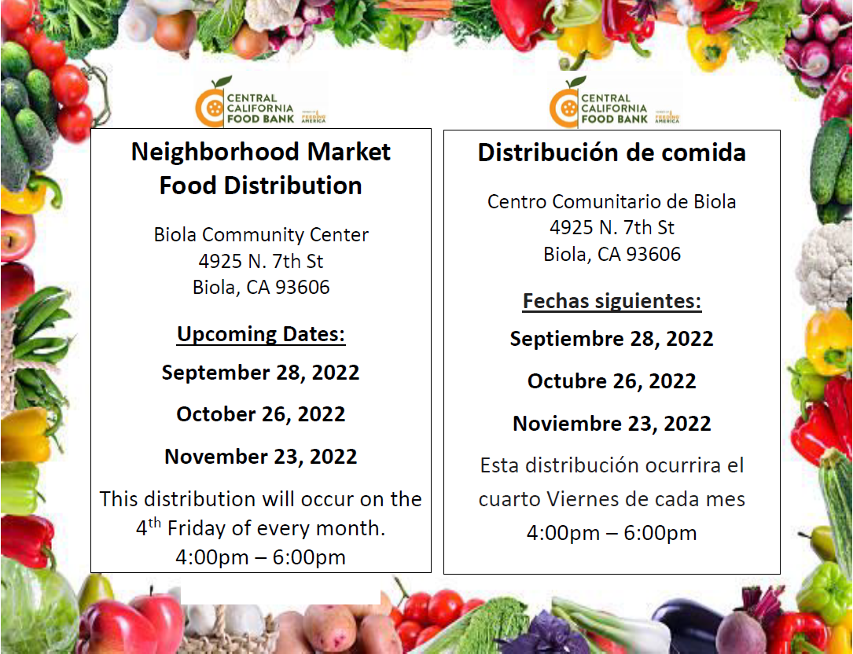

Effective June 1st, the new optional online payment system is available on our website. To register please visit www.biolacsd.org and follow the online payment steps. For assistance, please call the office. If a payment is not received by the 15th of every month, a late payment will be applied.
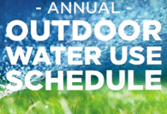
3 DAY WATERING SCHEDULE: April 1,2022 - October 31,2022
Addresses ending in odd numbers (1,3,5,7,9): Tuesdays, Thursdays, Saturdays. Addresses ending in even numbers (0,2,4,6,8): Wednesdays, Fridays, Sundays. NO WATERING between 10 a.m.- 6 p.m. and NEVER on MONDAYS.
“No parking in alley’s allowed, unauthorized alley parked cars will be towed away at owner’s expense.” “Prohibido estacionarse en el Callejon, autos estacionados en el Callejon seran remolcados al costo del dueño del auto.”
Please help us keep Biola Graffiti free. Report graffiti activity (559) 600-3111 Thank you
Ayúdenos a reportár el Grafiti. Por favor de llamar al (559) 600-3111 Gracias.
Thank you for your continuous efforts in keeping our Community of Biola clean, safe and sound, and for doing your part in keeping your property clean as we continue our TEAMwork. “Together Everyone Achieves More.”

